**WEATHER INFORMATION DISSEMINATION SYSTEM (WIDS) SAMPLE USER MANUAL.**

**Web Version**

**Version 1.0**

**July 2017**

**Introduction to the User’s Guide**

WIDS is a component of the WIMEA system that aims at providing a platform for the Meteorological Authority to input data that is captured and from different weather stations, in suitable formats understandable to the association and provide those values to the general public in form of weather forecasts, advisories to the people and other important information that can be delivered to the public in general in as regards to the weather patterns monitored.

The Dissemination system comprises two (2) versions or components namely the USSD and SMS component and the Web Component.

The USSD version will be a short request-response component where people can request for quick information from the options provided and be provided with responses in form of text messages.

The Web version is a more detailed component that has more functionality including getting visual, audio and graphical information for the user requests with the ability of showing more information about the weather forecast categories and advisories.

The WIDS component stores and generates its data from a dissemination repository that includes all weather data needed to provide and project the required information to the general public.

**How to access the Dissemination system.**

For one to log into the system as an administrator, he/she should have had their login credentials added by the administrator and approved prior to logging in.

The administrator has to offer these credentials to the various users of the system who are to input the information about the advisories.

The general users of the system will not have to log in to view this information since it is a dissemination system that provides general information to the public about weather and its related activities.

For the USSD component, users will only have to access the initial menu of the system by inputting a USSD code into their phones and be redirected by their respective mobile telecom companies to the menu of the system where they can get all the information they require.

**Log In**

The administrator users will have to provide the username and password at the log in prompt in order to access the administrative view from where information will be entered.

The username must be inform of an email address and the password will be the password of choice of the user going to access the system.

The log in prompt of the system will be represented as below on the web component.

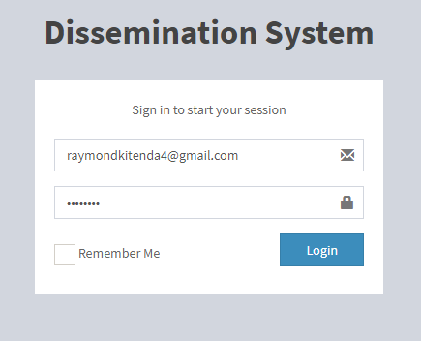

Figure 1: Log in for Administrator

In order to access the web version, it is a requirement for the user to have internet access.

For the USSD, version, in order to get information the user should have at least 200Ush on their mobile phones.

A wrong username or password, will provide an alert for entry of new and correct username and password.

A correct username and password will take the authenticated user to the correct administrator view for the system with appropriate menus for inputting all the required information.

The current username and password for testing purposes is [ad@admin.com](mailto:ad@admin.com) and password is **admin**

**The Dissemination System main window.**

The dissemination system main window will have appropriate menus depending on which administrator/specialist/official is logged in.

Figure 2: Default page for administrator

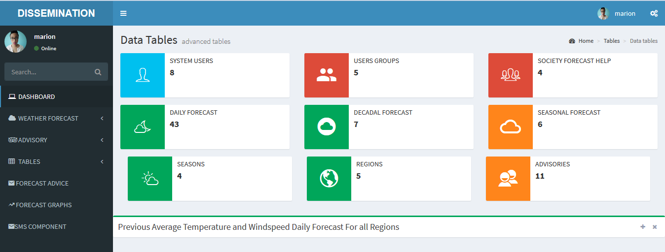

When logged in as a systems administrator/specialist the above page is what is shown which has a menu that only provides options for the person who is logged in, different systems statistics and graphs showing different weather parameters for the previous days.

**Data Capture and Input**

On the administrator view, data is entered into the system through forms where the user has to input data values captured from their predictive models or from the forecasts of UNMA.

**Data Entry Forms**

**WEATHER FORECAST ENTRY FORMS.**

The Daily Forecast Form is used to capture daily forecast for the specific day being investigated.

1. It has fields to input the maximum and minimum temperature forecasts.
2. Next, you input the **sunrise** and **sunset** information which may include time.
3. You then input the **wind** speeds (as an integer) which represents wind speed in m/s.
4. On the option of ‘**Weather**’, you insert a brief description of the weather forecast for example, “An expectation of rain due to the low temperatures realized during the past three days”.
5. On the **advisory** option, depending on the weather forecast, one has to insert advisory for users of the system.
6. Under the **date and Time** option, the data entrant has to select a date from the calendar provided and also select a period for which the weather forecast is being made such as; morning or afternoon.
7. Under the **outlook** option, the entrant has to select a type of forecast summary from the ones provided which may include, ‘light showers’, ‘sunny intervals’, ‘rain’ and so forth.
8. On the **season** option, one has to select a specific season of the year for which he/she is inputting the daily forecast e.g ‘JANFEBMAR’, ‘APRMAYJUN’ etc.
9. After all the information has been filled with no null values, the entrant can then click **Create** and the data for daily forecast will be submitted into the system.

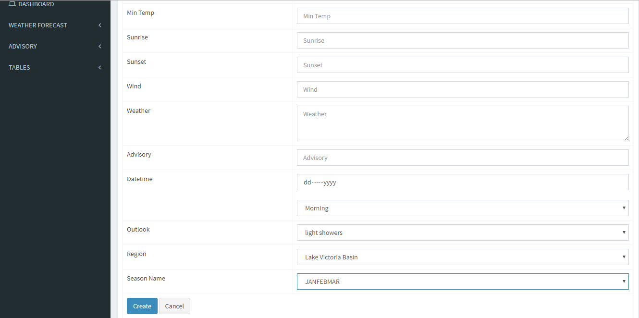

The dekadal Forecast Form is used to capture data options for displaying weather forecasts for the next ten successive days.

1. It has a field to input the advisory for the users according to the weather forecast that has been made for the next 10 days
2. Next, the entrant has to select a region from the available regions that are available in the list.
3. The entrant then has to select the date to start the forecast from the “Date-From” option from the calendar provided.
4. The entrant then has to select the end date for the forecast from the “Date-To” option from the calendar provided.
5. An audio and an image can also be added to the upload but is optional and can be uploaded with the forecast data if it is available.
6. After all the information has been entered, then, the user clicks **Create** to send the information into the system.

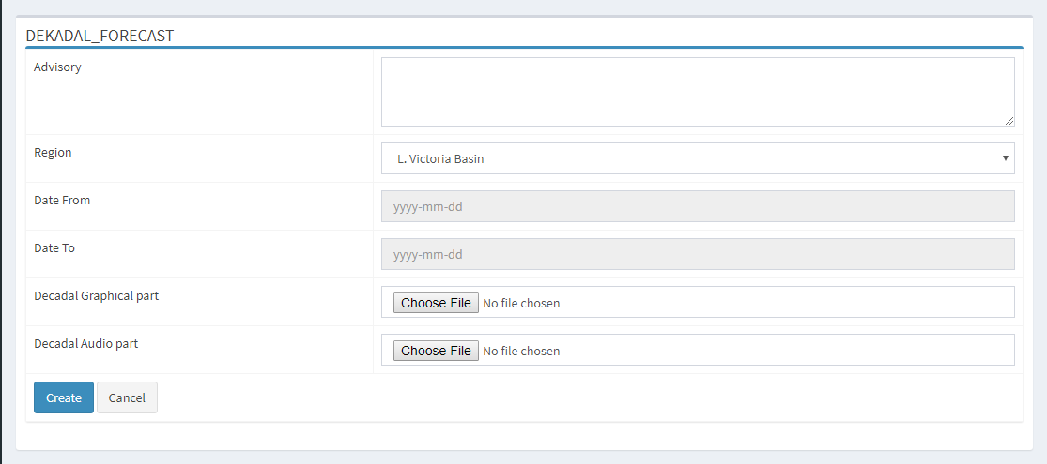

The Seasonal Forecast Form enables the entry of seasonal forecast data for the various seasons that are recognized during the course of the year.

1. The entrant has to first select a region for which this seasonal forecast is being made from the **Region** drop down list and after select a sub-region for which the forecast is being made
2. Next, the month for the start of the forecast is selected.
3. Then the month for the end of the forecast is also selected.
4. One then has to select the season from the list provided. Seasons are divided into three months e.g JAN-FEB-MARCH.
5. Sample default impacts are provided and the user has to check from the provided list to add to the impacts section.
6. If more impacts are needed and are not provided in the list, then the user can add more impacts in the impact text box.
7. An option is available to send images and audios if available before the user can submit the seasonal forecast.
8. Next, click “**Create**” and the seasonal forecast is entered into the system.

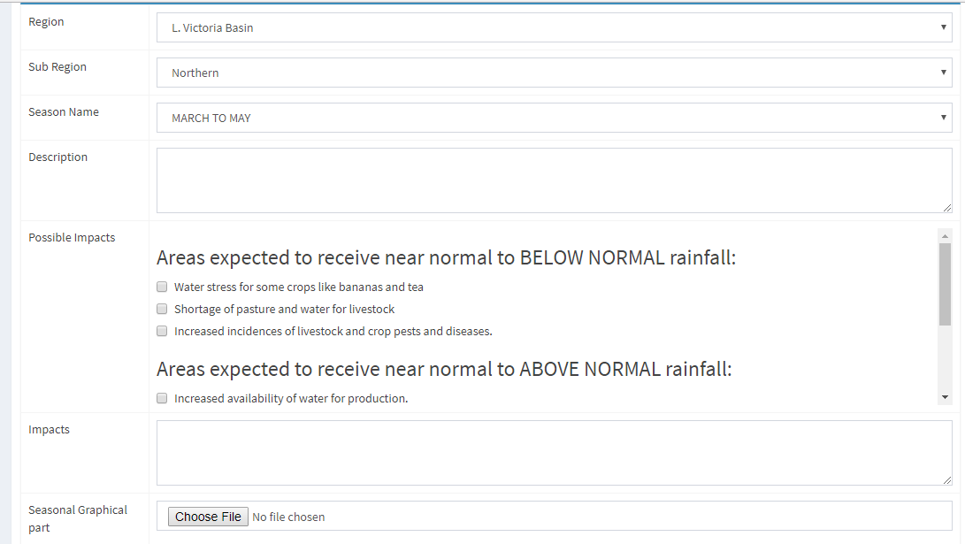

**ADVISORY ENTRY FORMS**

The advisory entry forms are for entering advisory information related to

agriculture, food, water and other weather affected areas.

Each specialist will only have access to his/her respective advisory category.

1. The entrant selects the region and sub-region for which the advisory is.
2. Then he/she selects the specifics of the advisory for example, planting advice, pests and diseases, etc
3. Then one selects some default advisories from the ones provided under “Possible Advisories”.
4. In case an extra message is needed, it is placed in the message text area.
5. An audio can also be added to the advisory if available.
6. The user then clicks create to add the advisory to the system.

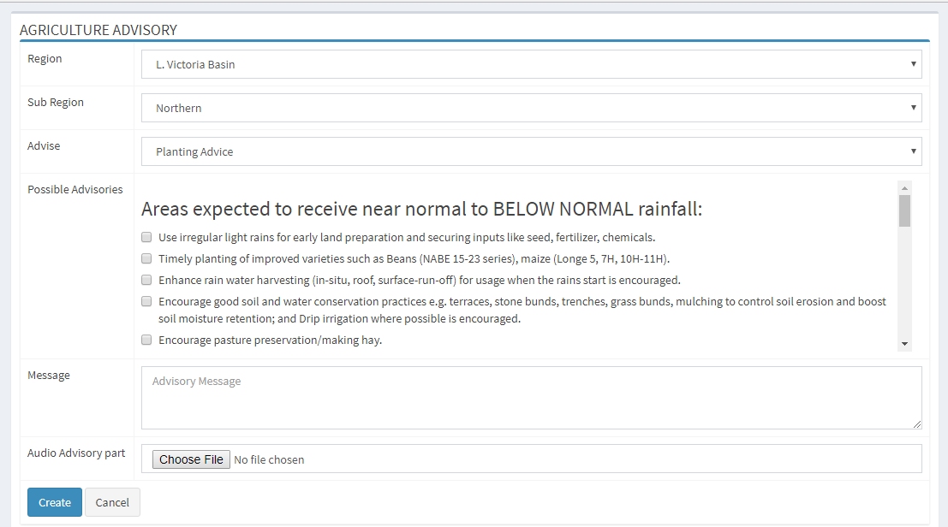

**VIEWING AND FORMATTING DATA**

When an administrator wants to view the submitted information about weather forecast and advisories, he can use the View Tables option on the side bar menu.

This option enables one to view uploaded information, make changes to that information and delete information from the list of what is submitted.

The data in the view tables menu comes with options to view, edit and delete that specific row of information selected.

When one wants to keep records of this data for further report generation or viewing, there are three options ie. **Convert to PDF**, **Convert to Excel** or **Convert to word.**

These options convert the tabular data returned into their respective formats.

Each type of forecast or advisory has its respective data tables and menus to allow editing, formatting and viewing.

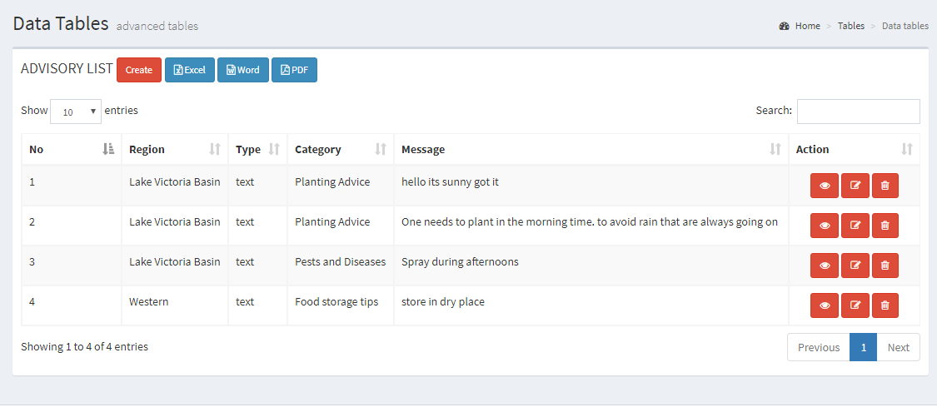

**GENERAL USER PLATFORM**

The general user of this system will not have to login in order to access the information about weather dissemination.

The general users of the system comprise farmers, farmers associations, general public and so on.

The users will have to access the system in order to request for information and advisories about weather conditions in different periods like daily, dekadal and seasonal and also advisories on agriculture with regards to the weather forecast details.

The home page of the user will have a menu for selecting the required option and results will be displayed.

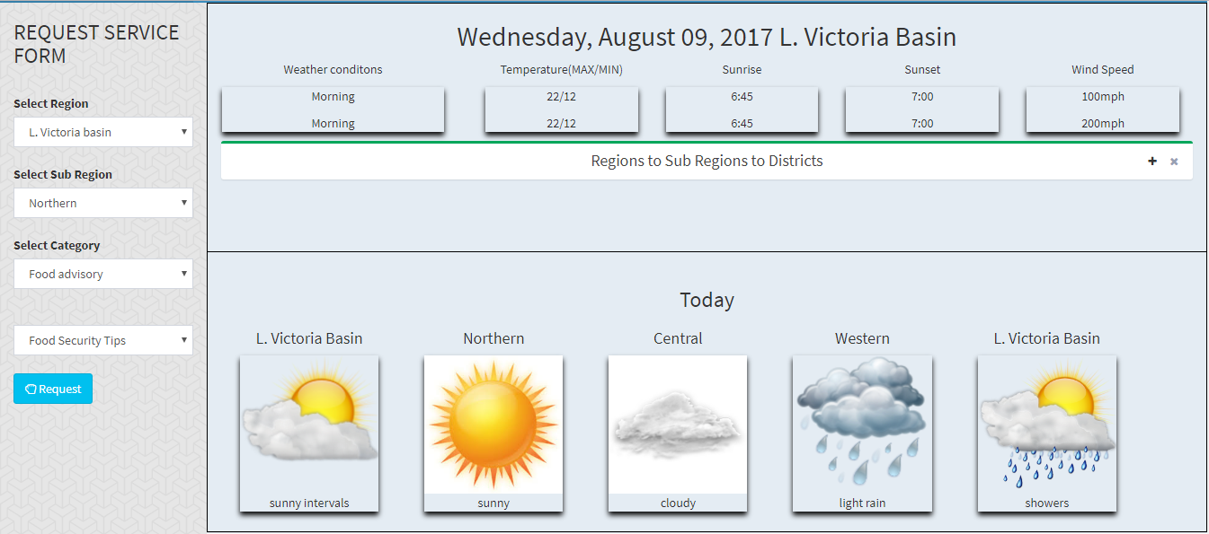

**REQUESTING FOR INFORMATION**

A user can request for information pertaining to the agricultural and food advisories and also for weather information.

1. Select the region for which you want a forecast or advisory.
2. Select the category of advisory you require e.g weather, agricultural and food
3. The selected major category influences the menu of subcategory that appears after.
4. The user then selects the specific advisory he intends to view, ie. For food advisory, the options are, food security tips, hunger forecast and food storage tips.
5. The user then clicks request to get advisory or forecast.

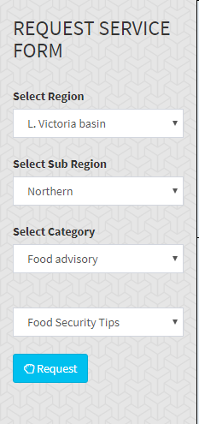

After a user selecting the kind of advisory or forecast he/she requires, all results will be returned in tabs that will separate text, graphical and audio.

The results of the selected advisory will be as shown;

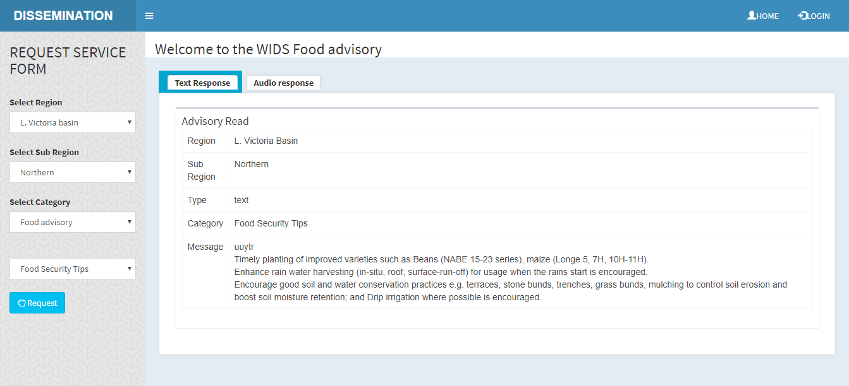

**INDIGENOUS FORECAST ADVICE**

This is a section that deals with weather forecasts provided by the locals to UNMA as a way of maintaining their involvement with the system.

1. The user selects the feedback option and the region from the request service form.
2. A user has to insert his/her name or the name of an organization if this indigenous forecast is coming from an organization.
3. The feedback is then entered as the user wishes it to be and uploads it.